# 📦 Curso: Despliegue de Aplicaciones con Docker

## 🎓 Información del Curso

* **Curso:** Despliegue de Aplicaciones con Docker
* **Proyecto:** Práctica de Docker Compose
* **Profesor:** Ing. Edison Naranjo (CEC-EPN)
* **Fecha:** 19 de Septiembre de 2025

## 📑 Proyecto – Análisis de Vulnerabilidades y Despliegue Automático con Docker Hub - Grupo 1 – Tarea 3

### 📋 Descripción del Proyecto

Este proyecto implementa una aplicación **FastAPI** en GitHub y un archivo **.yml** en GitHub Actions para:

1. Realizar análisis de vulnerabilidades de la aplicación.
2. Construir la imagen Docker.
3. Publicar la imagen automáticamente en **Docker Hub**.

## 👥 Integrantes - Grupo 1 (Municipio de Quito)

| **Integrante** | **Repositorio GitHub** |
| --- | --- |
| Carpio Zaquinaula Byron Orlando | <https://github.com/bcarpio16/fastapi-app-scout.git> |
| Villarroel Vera Milton Orlando | <https://github.com/movillarroel/fastapi-app-scout.git> |
| Mena Segura Edison Fabián | <https://github.com/Bulls1168-C/fastapi-app-scout.git> |
| Benavides Freire Alex Vicente | <https://github.com/abenavides86/fastapi-app-scout.git> |
| Gallardo Nicolalde Marcelo Iván | <https://github.com/panivinux/fastapi-app-scout.git> |

Archivo workflow YAML de GitHub Actions 🚀

name: Build and Analyze Docker Image

on: push: branches: [ "main" ]

env: IMAGE_NAME: *panivinux*/fastapi-app-scout

SHA: ${{ github.sha }}

jobs: build-and-analyze: runs-on: ubuntu-latest

steps:

- name: Checkout repository

uses: actions/checkout@v4

- name: Log in to Docker Hub

uses: docker/login-action@v3

with:

username: ${{ secrets.DOCKERHUB_USERNAME }}

password: ${{ secrets.DOCKERHUB_TOKEN }}

- name: Set up Docker Buildx

uses: docker/setup-buildx-action@v3

- name: Build image and load to runner

id: build

uses: docker/build-push-action@v6

with:

context: .

file: ./Dockerfile-single

push: true

load: true

tags: ${{ env.IMAGE_NAME }}:sha-${{ env.SHA }}

- name: Install Docker Scout

run: |

mkdir -p ~/.docker/cli-plugins

curl -sSfL https://raw.githubusercontent.com/docker/scout-cli/main/install.sh | sh

sudo cp ~/.docker/cli-plugins/docker-scout /usr/local/bin/

docker-scout version

# 6. Escanear la imagen con Docker Scout

- name: Scan image with Docker Scout

run: |

echo "🔍 Ejecutando análisis de vulnerabilidades con Docker Scout..."

docker scout cves ${{ env.IMAGE_NAME }}:sha-${{ github.sha }} --output json 2>&1 | tee scout-report.json

echo "==== Resumen de vulnerabilidades detectadas ===="

cat scout-report.json

# 7. Subir reporte como artefacto en GitHub Actions

- name: Upload Scout JSON report

uses: actions/upload-artifact@v4

with:

name: docker-scout-report

path: scout-report.json

### 📋 Carpio Zaquinaula Byron Orlando

[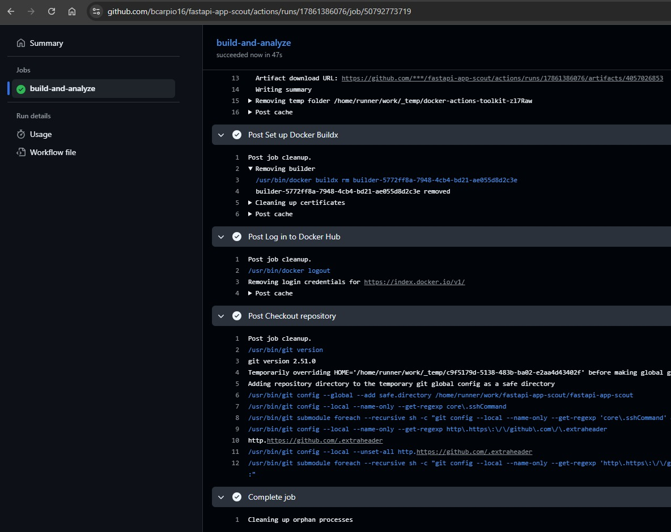](https://github.com/panivinux/fastapi-app-scout/raw/main/img/bc1.jpg)

[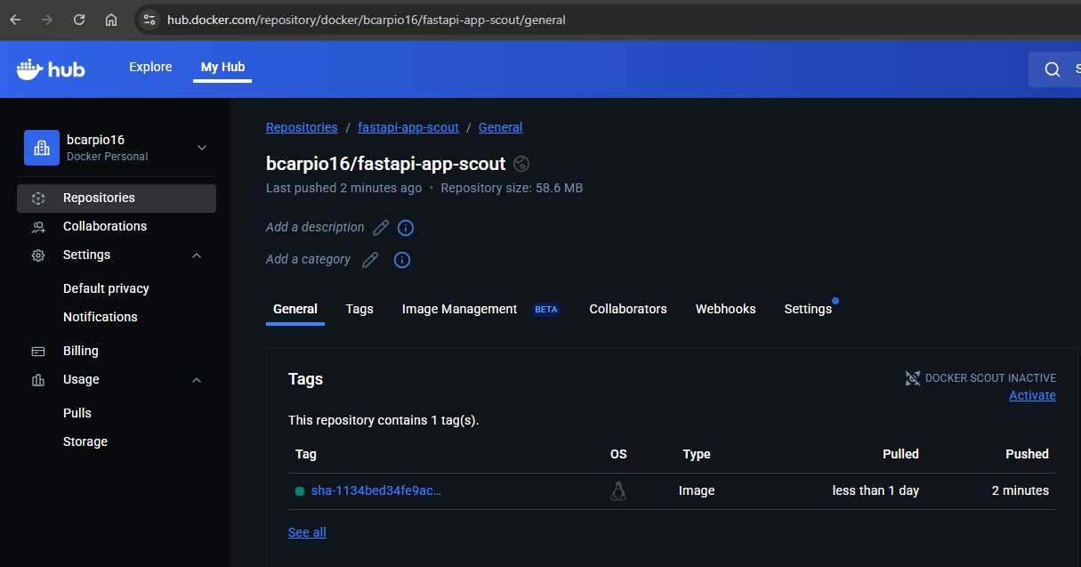](https://github.com/panivinux/fastapi-app-scout/raw/main/img/bc2.jpg)

### 📋 Villarroel Vera Milton Orlando

[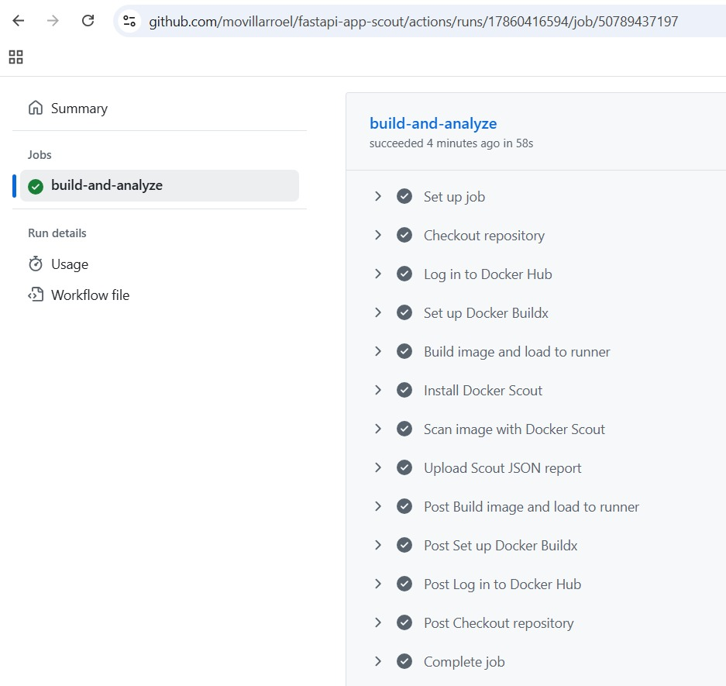](https://github.com/panivinux/fastapi-app-scout/raw/main/img/mv1.jpg)

[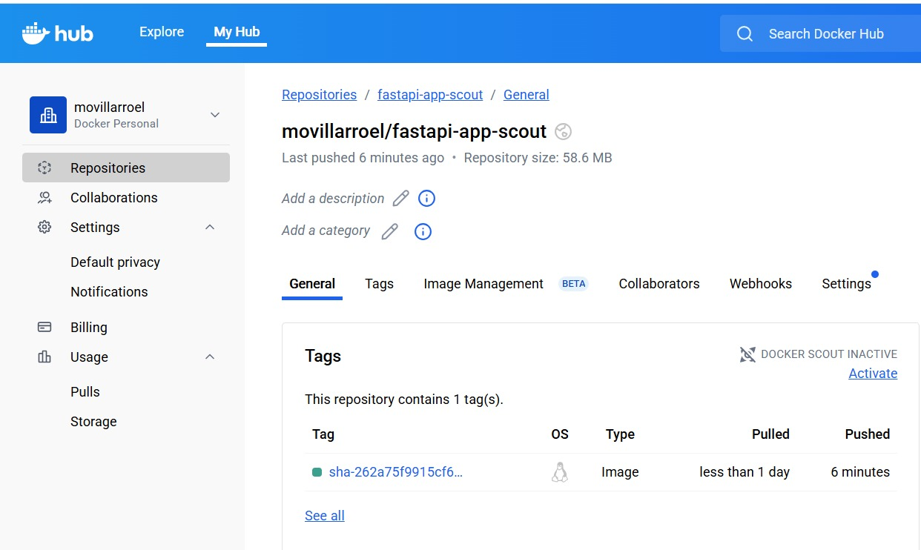](https://github.com/panivinux/fastapi-app-scout/raw/main/img/mv2.jpg)

### 📋 Mena Segura Edison Fabián

[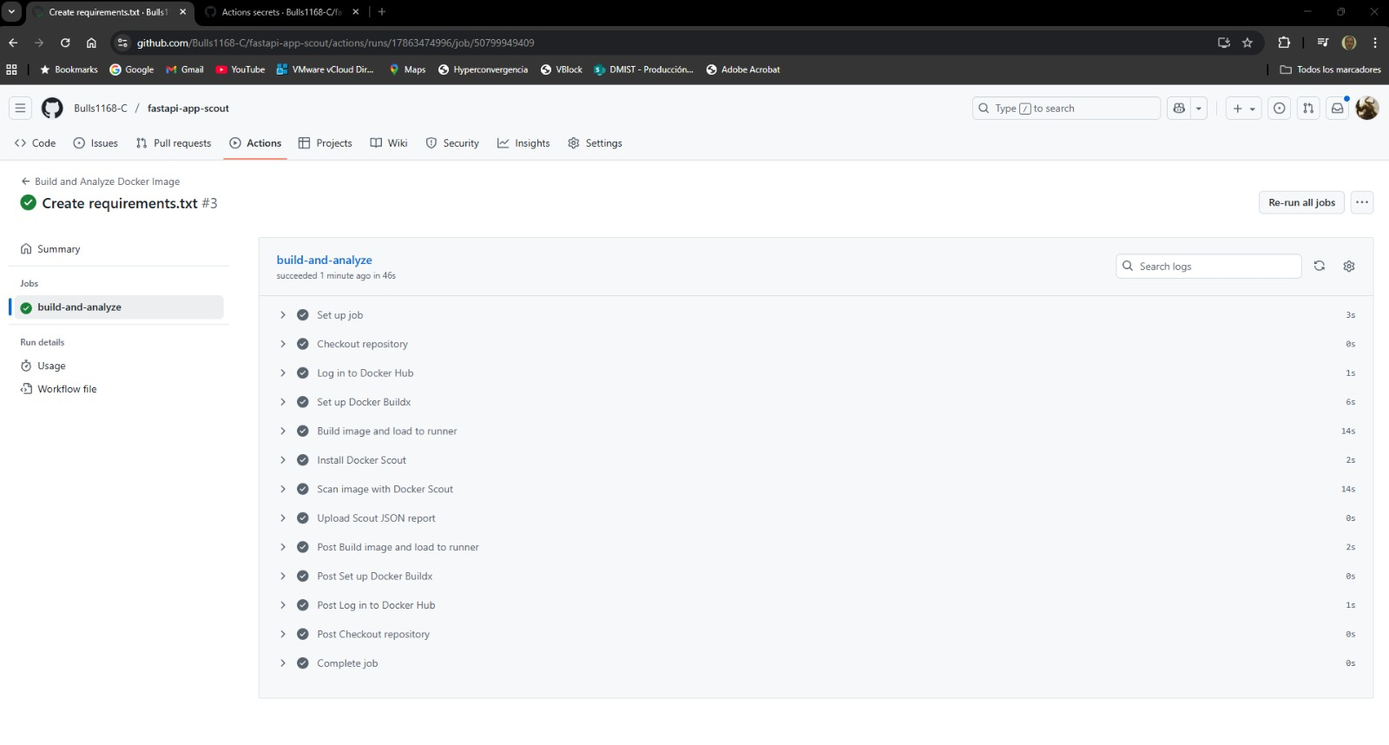](https://github.com/panivinux/fastapi-app-scout/raw/main/img/em1.jpg)

[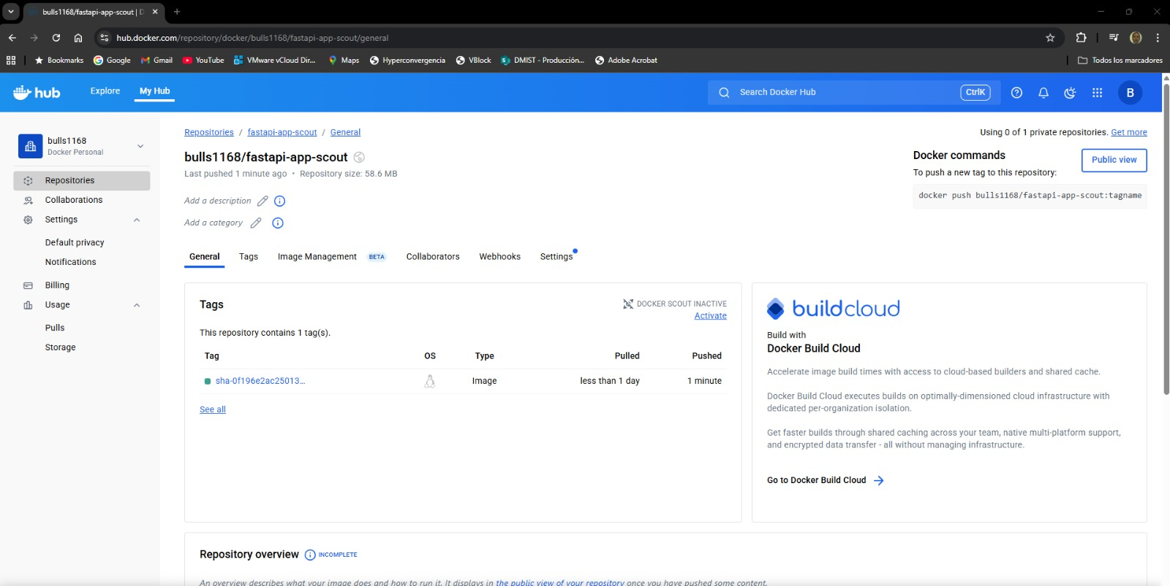](https://github.com/panivinux/fastapi-app-scout/raw/main/img/em2.jpg)

### 📋 Benavides Freire Alex Vicente

[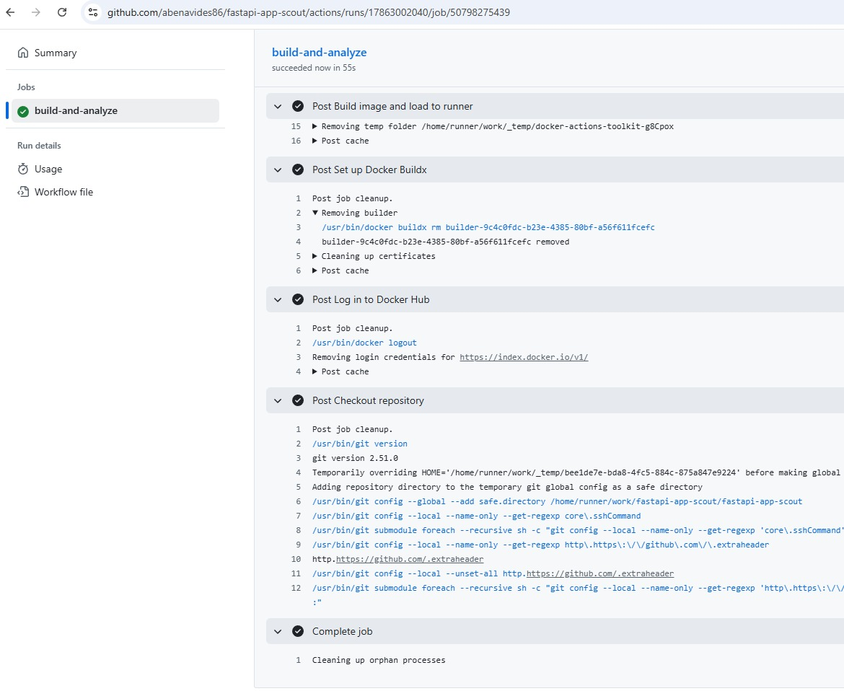](https://github.com/panivinux/fastapi-app-scout/raw/main/img/ab1.jpg)

[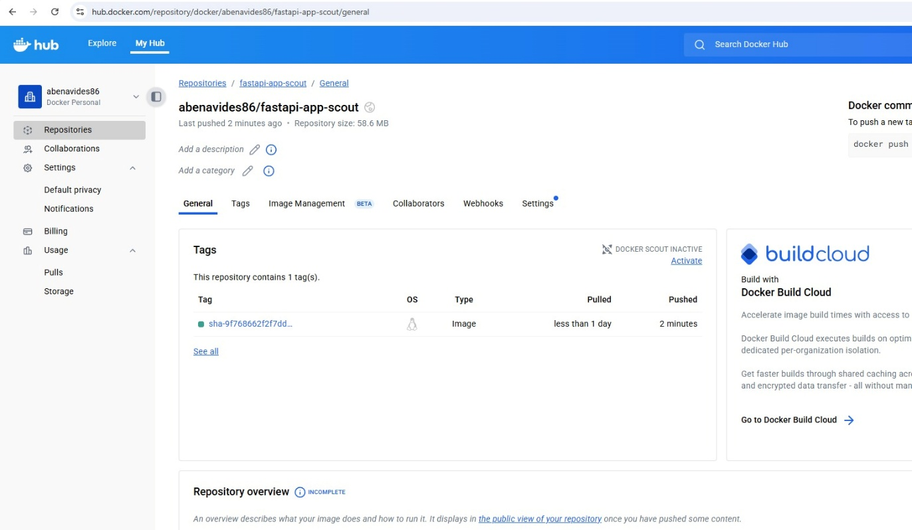](https://github.com/panivinux/fastapi-app-scout/raw/main/img/ab2.jpg)

### 📋 Gallardo Nicolalde Marcelo Iván

[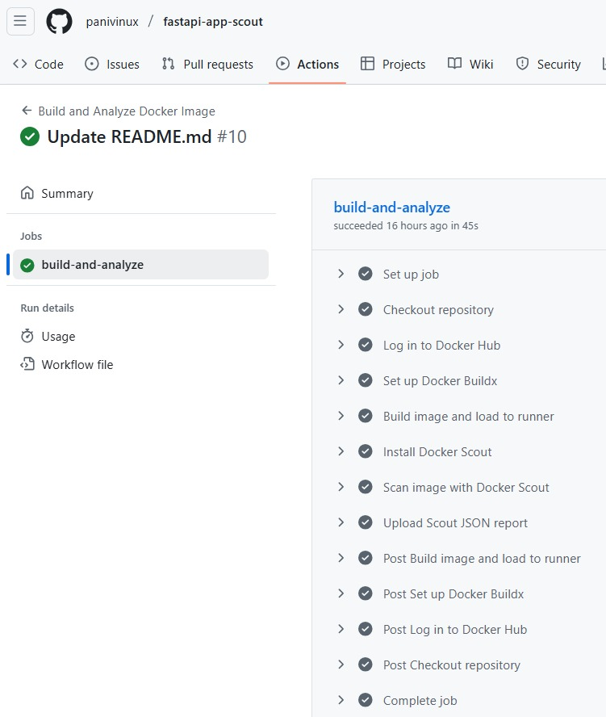](https://github.com/panivinux/fastapi-app-scout/raw/main/img/mg1.jpg)

[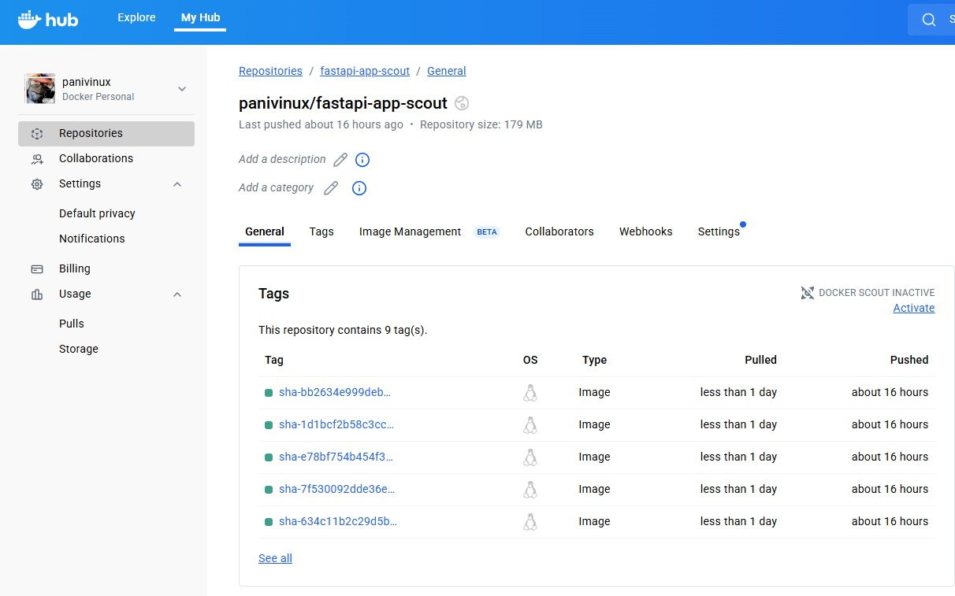](https://github.com/panivinux/fastapi-app-scout/raw/main/img/mg2.jpg)